# Enterprise Level Configuration

# App Level configuration

## Request Account access from App-Team

### Process

Requestor (App-team) need to provide details required to create a user in SendGrid account in the form of excel (refer 2.1.2) to the GIS-Team. GIS-Team need to approve and add few details in excel and send to operation team. All the necessary fields (marked as “*”) should be filled with valid information, considering the optional fields also.

Note:

* If any necessary fields found to be empty or blank, the request will be revert back to the requestor.
* If any optional fields found empty, will be filled with the default value.

GIS-Team needed to provide the following details:

* All the SendGrid accounts provisioned in “Prod and Non-Prod” Environment.
* Key vault Account access to store the credentials of the account owner’s password.
* Default values will be define by them only.

Flow:

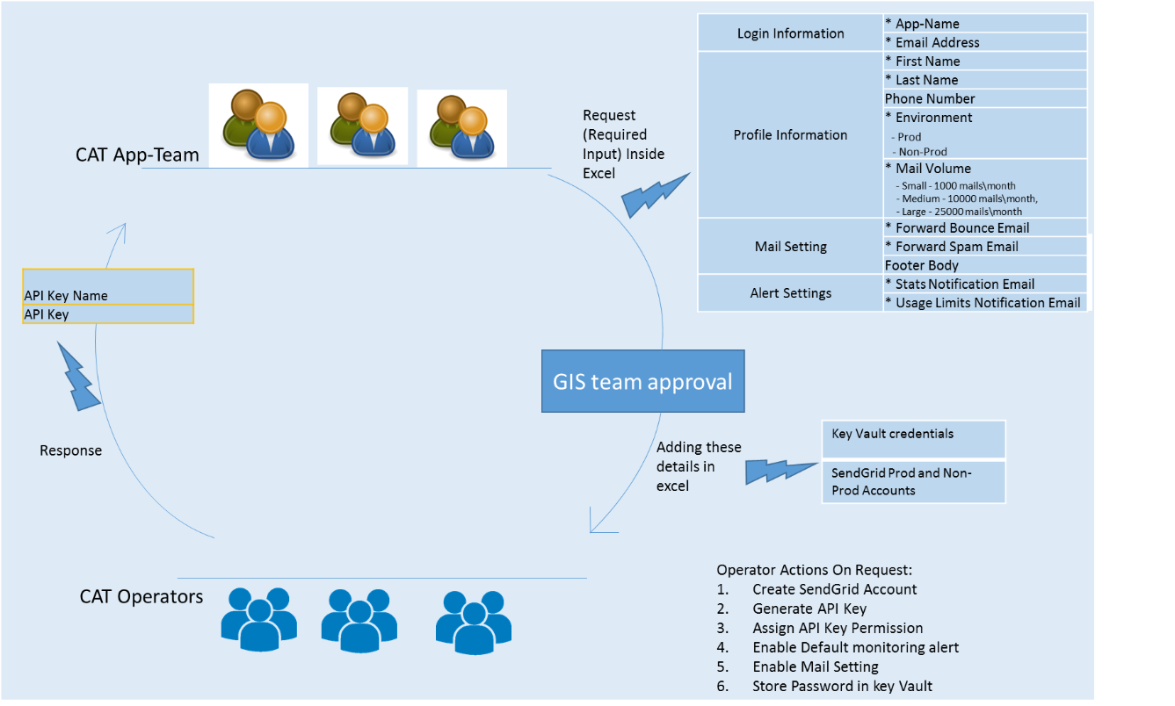

### Input Template

## Setting up Application access